**Tableau insight: Unemployment rate in India during covid-19**

**Project description:**

**Unemployment is a serious problem which is being experienced by most of countries throughout the globe. Nevertheless, in the developed nations it was experienced in its severe form at the time of the great depression (1930’s) while in the developing nations it was after the Second World war (1945).**

**In India Unemployment is considered a curse of development particularly the literate unemployed. In India, any person working about 8 hours a day 273 days annually is considered as employed on a standard person- year basis. Thus, a person to be called an employed person must get meaningful work for a minimum of 2184 hours in a year. The person, who does not get work for this duration, is known as an unemployed person.**

**Problem statement:**

**The objective of the project is how the lockdown affects employment opportunities and how the unemployment rate increases during Covid-19.**

**Analysing the dataset to get insights of**

1. **How Covid-19 affects the employment**
2. **How far the unemployment rate will go**

**Social impact:**

**The visualizations of India’s unemployment rate during the Covid-19 pandemic can shed light on the socio-economic challenges challenge faced by the population.**

**Business impact:**

**For business operating in India, especially those reliant on consumer spending, understanding the unemployment rate during Covid-19 is crucial for strategic planning and decision-making.**

**Technical architecture:**

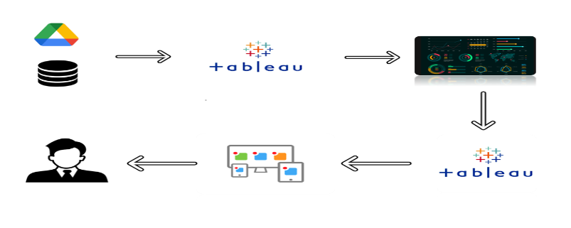

**Project Flow**

**To accomplish this, we have to complete all the activities listed below,**

**● Data Collection & Extraction from Database**

**o Collect the dataset,**

**o Connect data with Tableau**

**● Data Preparation**

**o Prepare the Data for Visualization**

**● Data Visualizations**

**o No of Unique Visualizations**

**● Dashboard**

**o Responsive and Design of Dashboard**

**● Story**

**o No of Scenes of Story**

**● Performance Testing**

**o Amount of Data Loaded**

**o Utilization of Data Filters**

**o No of Calculation Fields**

**o No of Visualizations/ Graphs**

**● Web Integration**

**o Dashboard and Story embed with UI With Flask**

**● Project Demonstration & Documentation**

**o Project Documentation-Step by step project development procedure**

**Milestone 1: Data Collection & Extraction from Dtabase**

**Data collection is the process of gathering and measuring information on variables of interest, in an established systematic fashion that enables one to answer started research questions, test hypothesis, and evaluate outcomes and generate insights from the data.**

**Activity 1: Collect the dataset**

**Please use the link to download the dataset1:** **link**

**Please use the link to download the dataset2:** **link2**

**Activity 1.1: Understanding the dataset**

**Data contains all the meta information regarding the columns described in the CSV files**

**Column Description of the Dataset:**

* **Date= Date which the unemployment rate observed**
* **Area= Areas which are rural and urban**
* **Region= States in India**
* **Estimated Unemployment Rate(%)= Percentage of people unemployed in each states of India**
* **Estimated Employed= Percentage of people employed**
* **Estimated Labour Participation Rate(%)= Labour force participation rate by dividing the number of people actively participating in the labour force by the total number of people eligible to participate in the labour force**
* **Frequency= Measuring frequency(Monthly)**

**Milestone 2: Data Preparation**

**Activity 1: Prepare the Data for Visualizations**

**Preparing the data for visualizations involves cleaning the data to remove irrelevant or missing data, transforming the data into a format that can be easily visualized, exploring the data to identify patterns and trends, filtering the data to focus on specific subsets of data, preparing the data for visualization software, and ensuring the data is accurate and complete. This process helps to make the data easily understandable and ready for creating visualizations to gain insights into the performance and efficiency.**

**Milestone 3: Data Visualization**

**Data visualization is the process of creating graphical representations of data in order to help people understand and explore the information. The goal of data visualization is to make complex data sets more accessible, intuitive, and easier to interpret. By using visual elements such as charts, graphs, and maps, data visualizations can help people quickly identify patterns, trends, and outliers in the data.**

**Activity 1: No of Unique Visualizations**

**The number of unique visualizations that can be created with a given dataset Some common types of visualizations that can be used to analyse the unemployment, employment, labour rate . Visualisations include bar charts, stacked bar charts, funnel chart, pie chart, dual line chart etc. These visualizations can be used to compare performance, track changes over time and relationships between variables, understanding the concept of unemployment during Covid-19 easily.**

**Activity 1.1: Estimated Unemployment rate in each state**

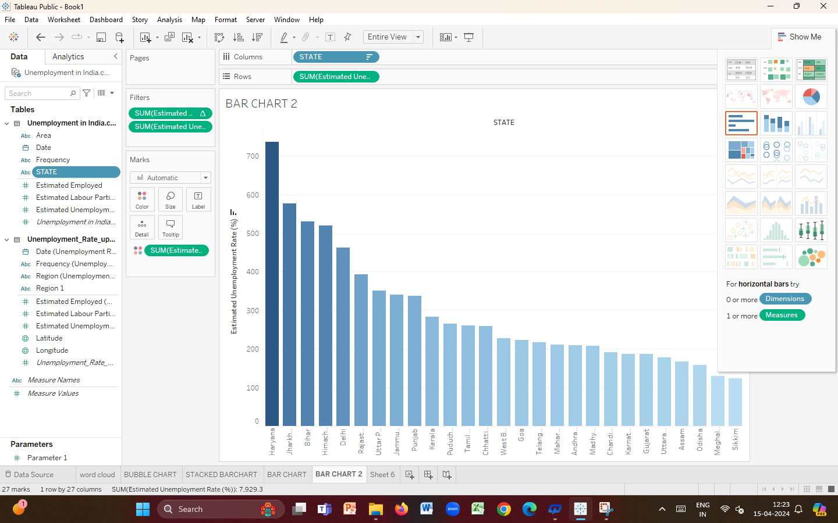

**Activity 1.2: Estimated unemployment rate in each month**

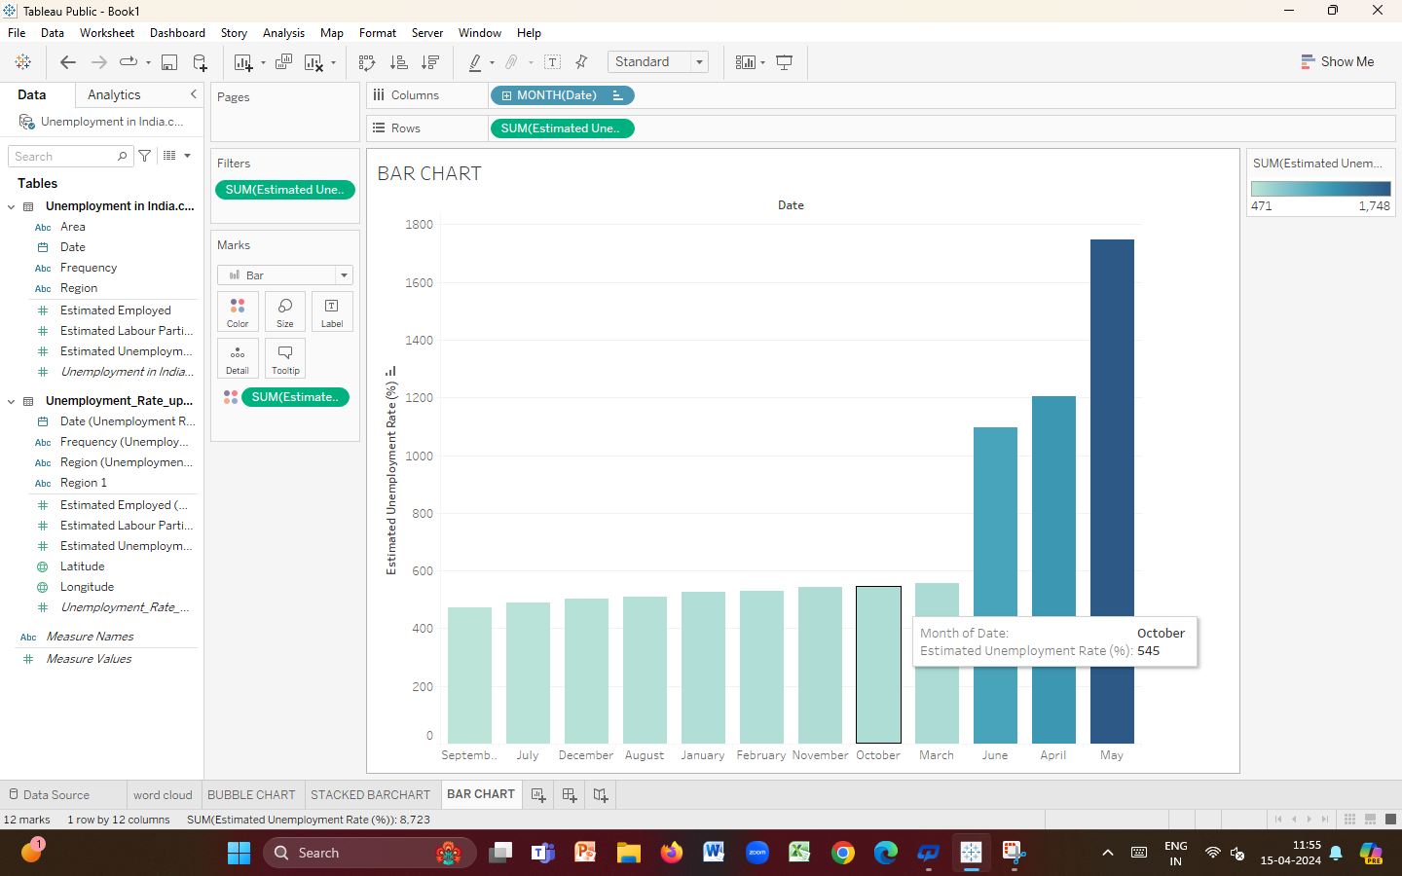

**Activity 1.3: Estimated employment and Unemployment rate in month of date**

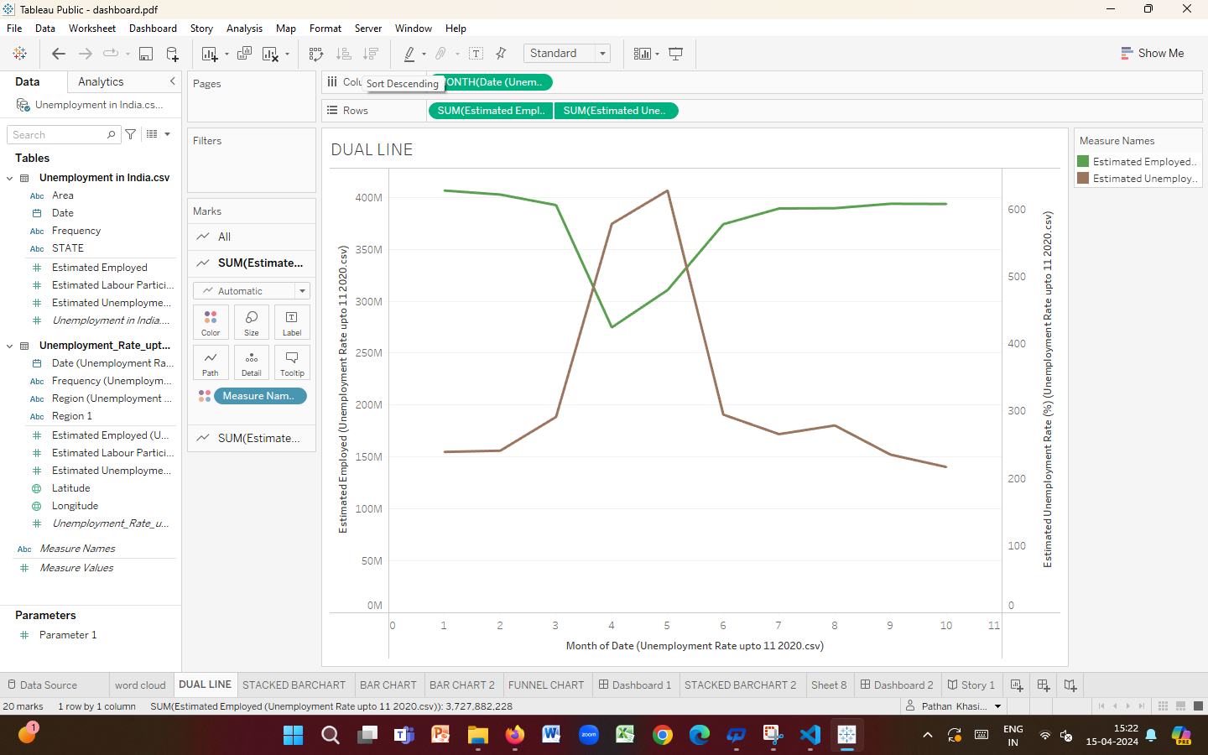

**Activity 1.4: Estimated employment rate in top 10 states**

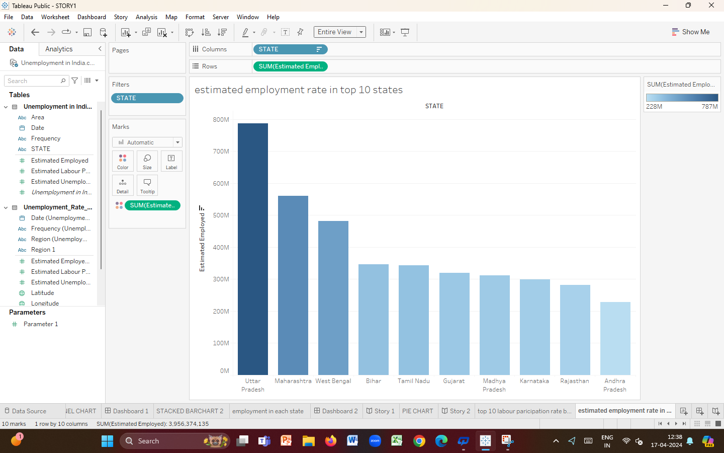

**Activity 1.5: Estimated employment in each state**

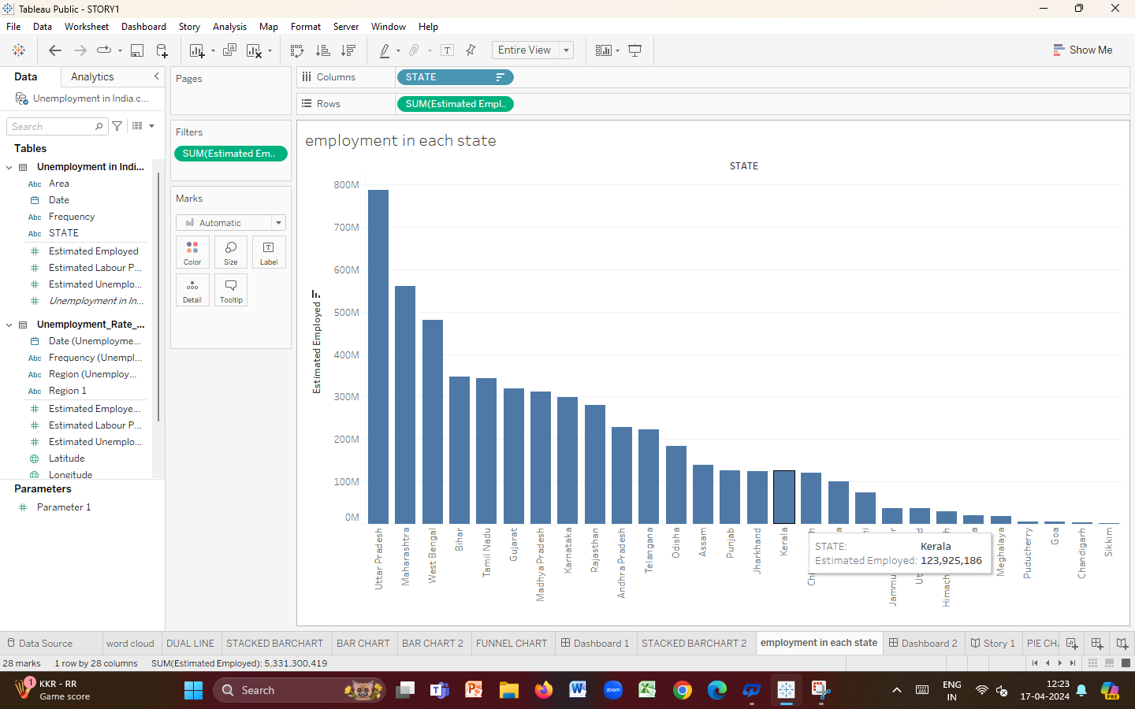

**Activity 1.6: Estimated unemployment rate(%) in each region**

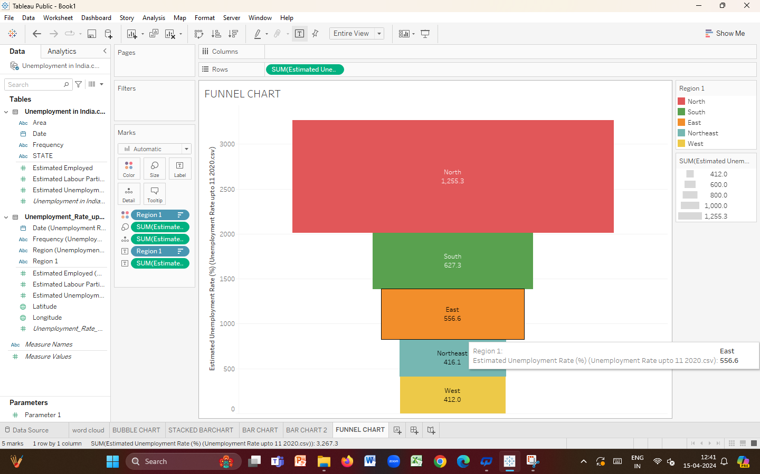

**Activity 1.7: Estimated labour participation, unemployment rate up to 11 2020**

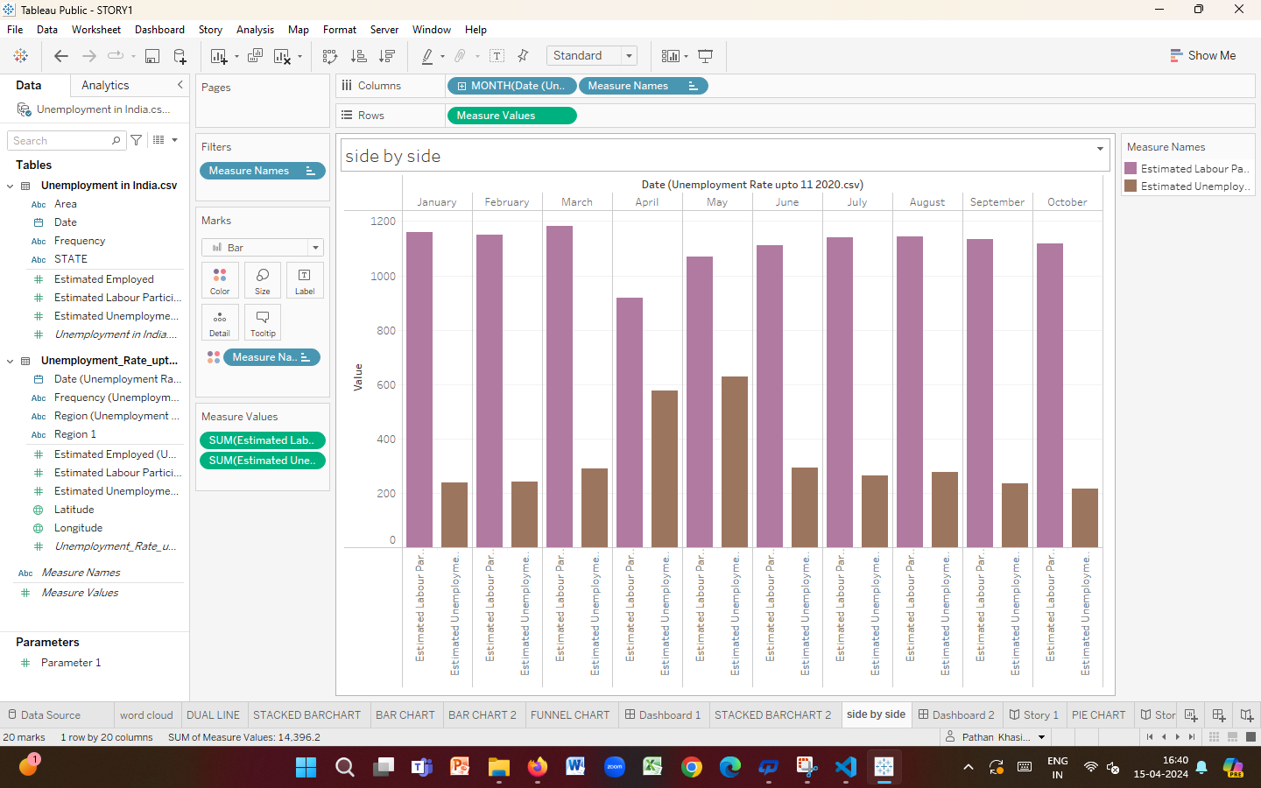

**Activity 1.8: Estimated employment and unemployment in rural and urban.**

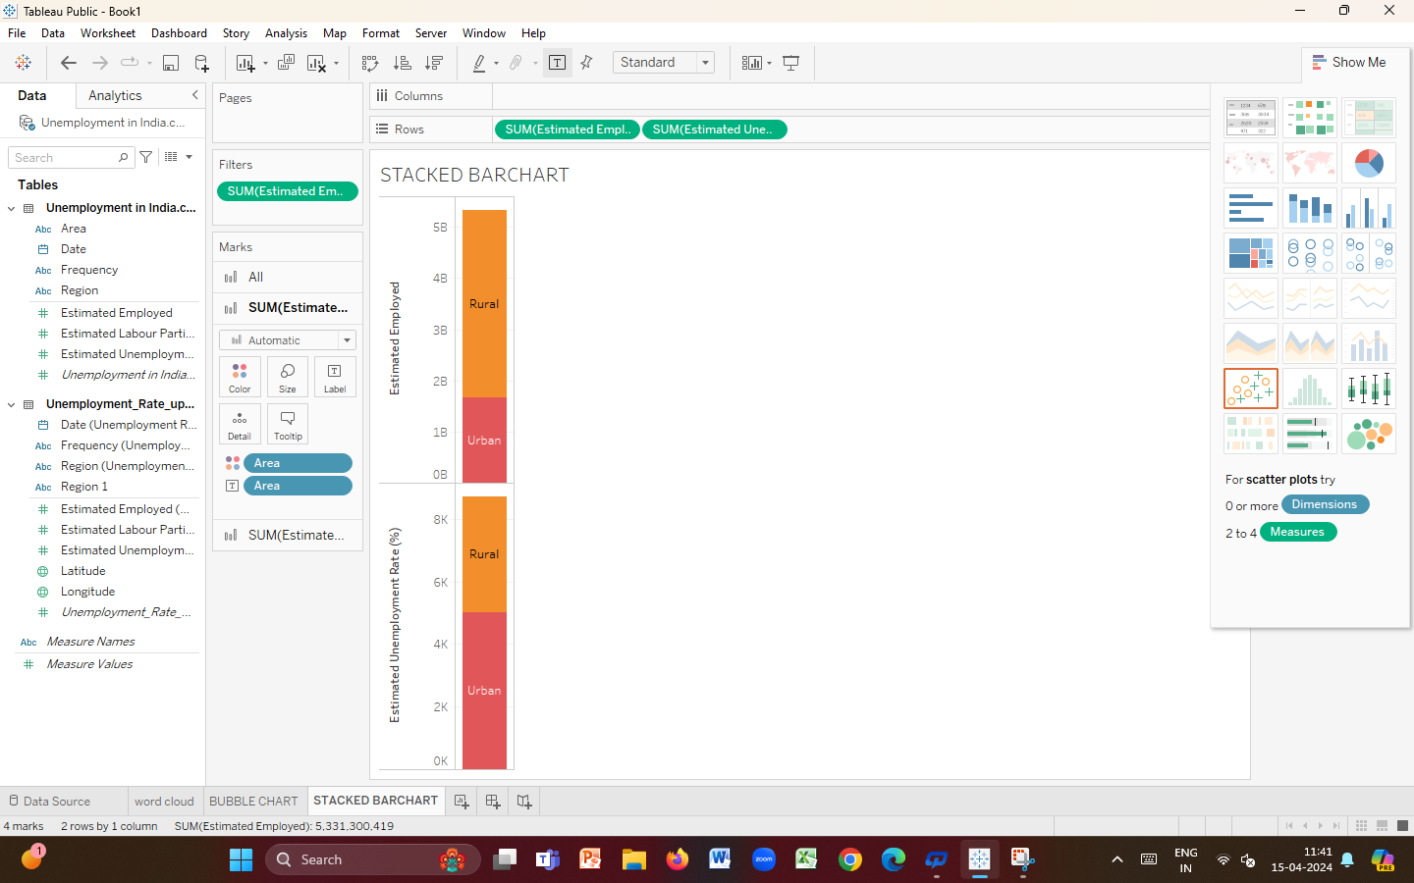

**Activity 1.9: Top 10 Labour participation rate by area**

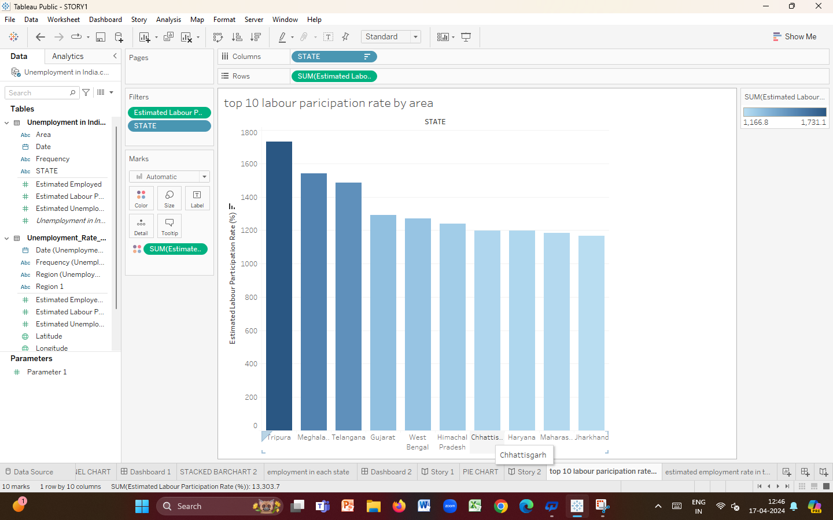

**Activity 1.10: Top estimated unemployment rate by state**

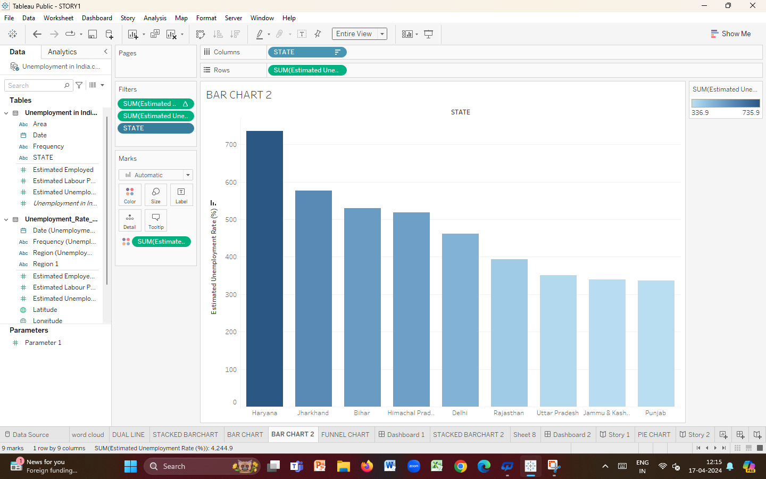

**Activity 1.11: Employment and unemployment rate in 2019,2020**

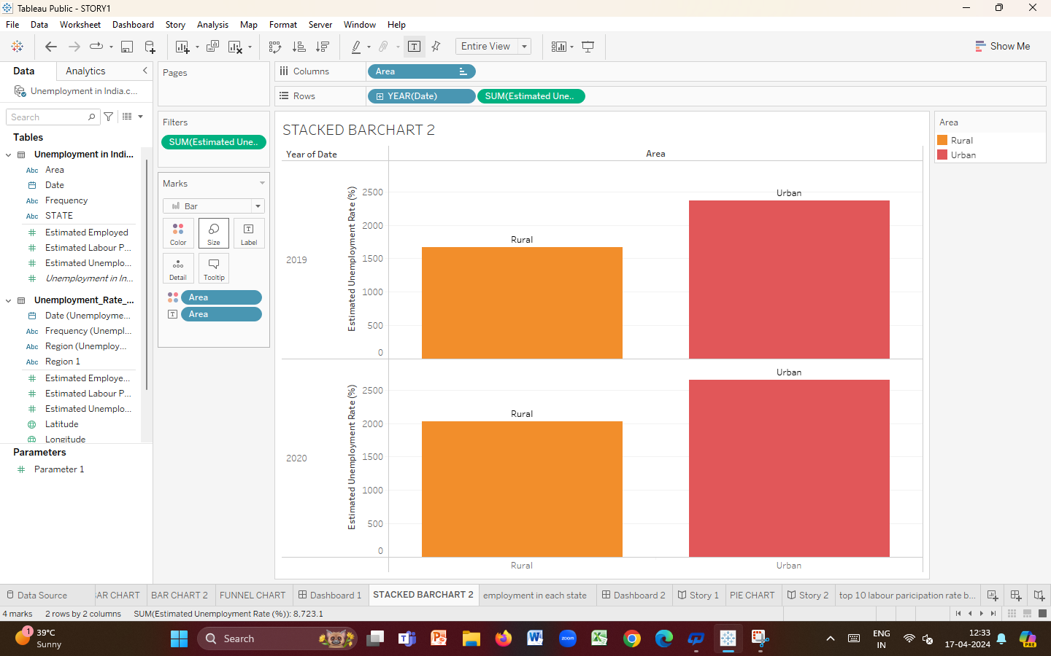

**ACTIVITY 1.12: ESTIMATED UNEMPLOYMENT RATE UPTO 11 2020 IN EACH REGION**

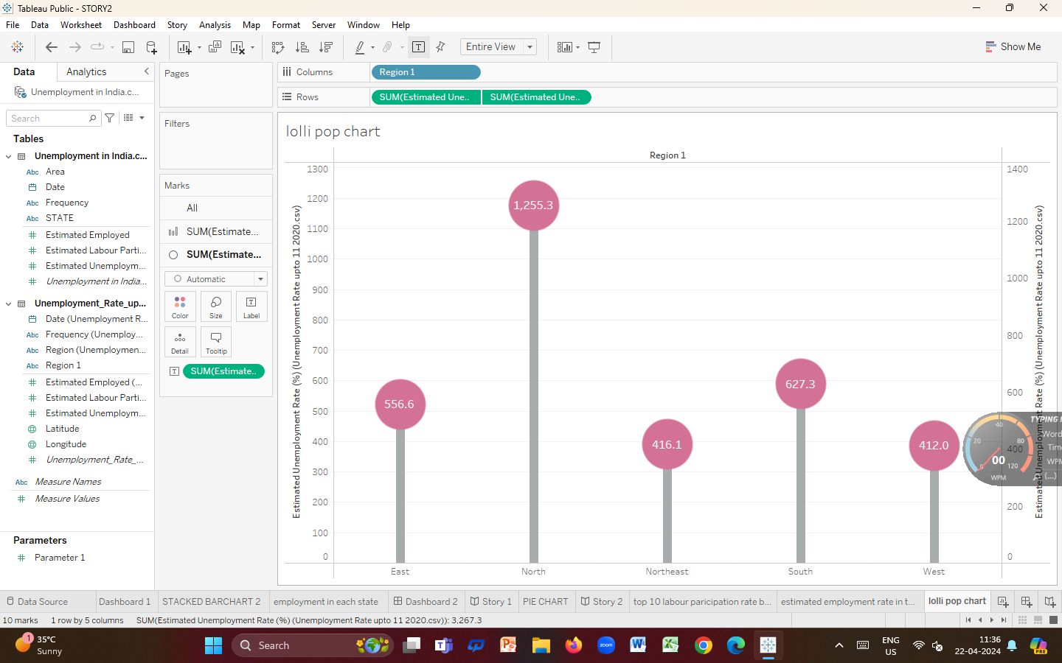

**Activity 1.13: Showing estimated employment and estimated unemployment in dual line**

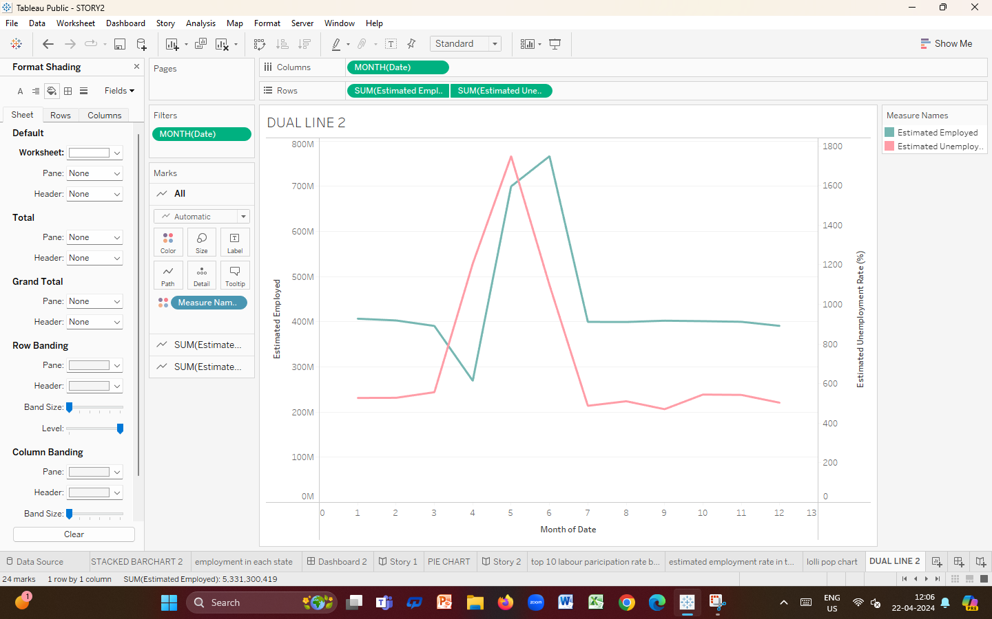

**Activity 1.14: Showing Estimated labour participation &unemployment in dual line**

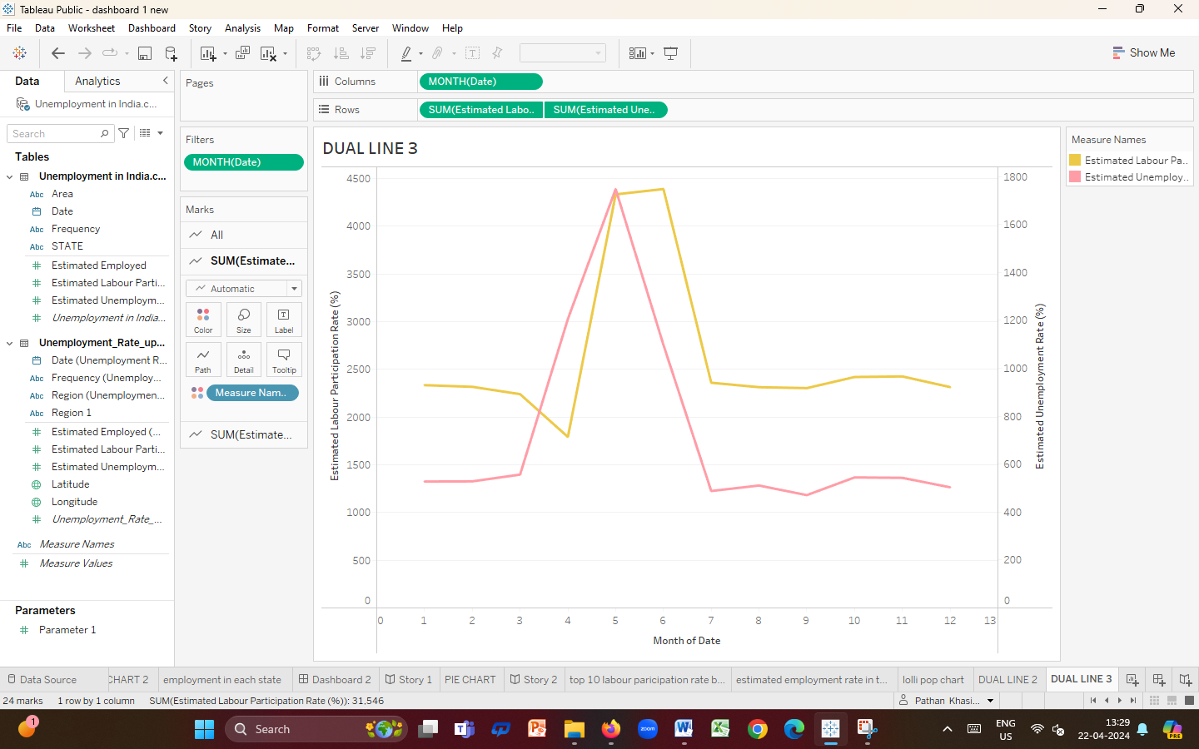

**Milestone 4:Dashboard**

**A dashboard is a graphical user interface (GUI) that displays information and data in an organized, easy-to-read format. Dashboards are often used to provide real-time monitoring and analysis of data, and are typicallydesigned for a specific purpose or use case. Dashboards can be used in a variety of settings, such as business, finance, manufacturing, healthcare, and many other industries. They can be used to track key performance indicators (KPIs), monitor performance metrics, and display data in the form of charts, graphs, and tables.**

**Activity :1- Responsive and Design of Dashboard**

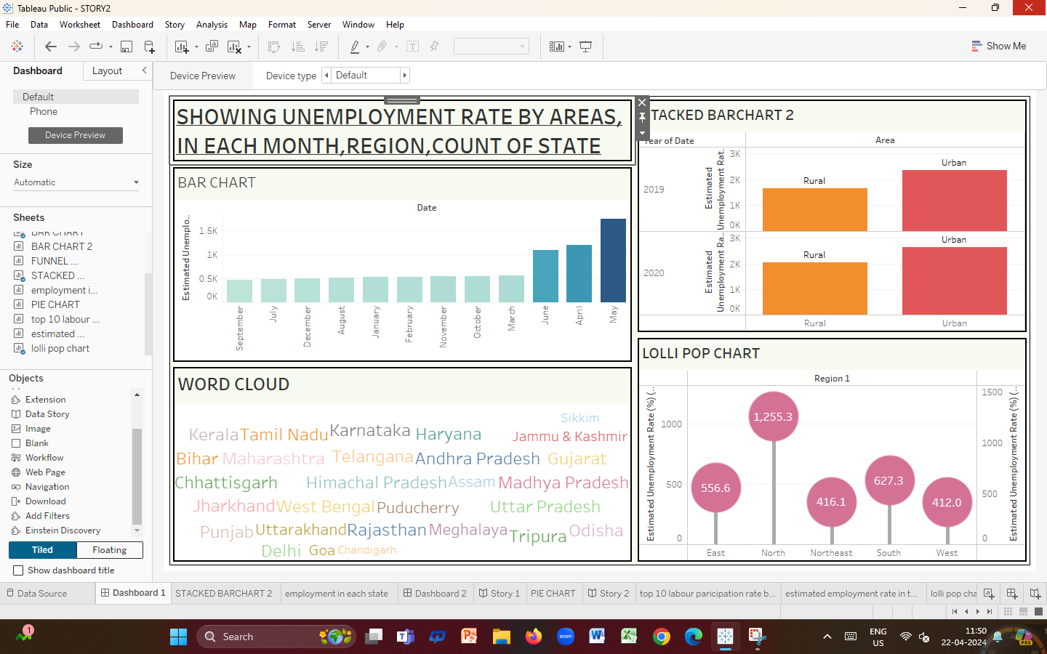

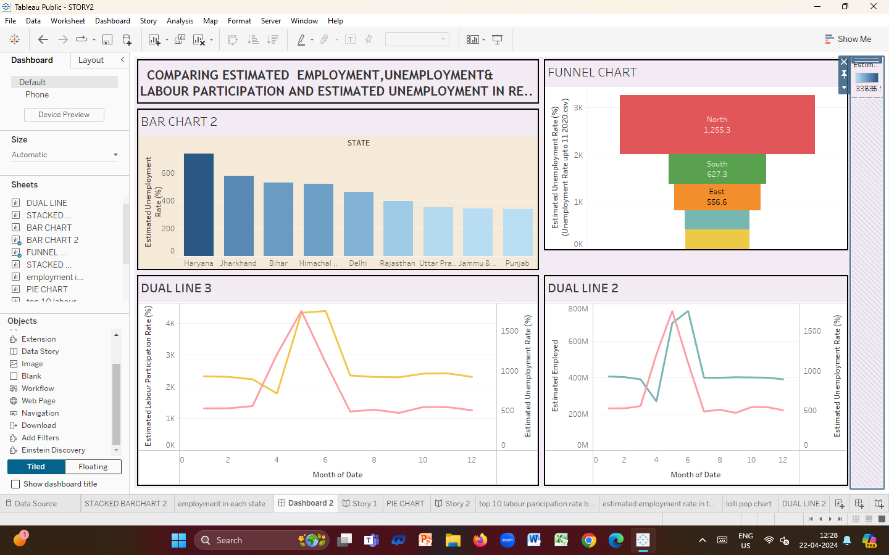

**Milestone 5: Story**

**A data story is a way of presenting data and analysis in a narrative format, with the goal of making the information more engaging and easier to understand. A data story typically includes a clear introduction that sets the stage and explains the context for the data, a body that presents the data and analysis in a logical and systematic way, and a conclusion that summarizes the key findings and highlights their implications. Data stories can be told using a variety of mediums, such as reports, presentations, interactive visualizations, and videos.**

**Activity 1: No of Scenes of Story**

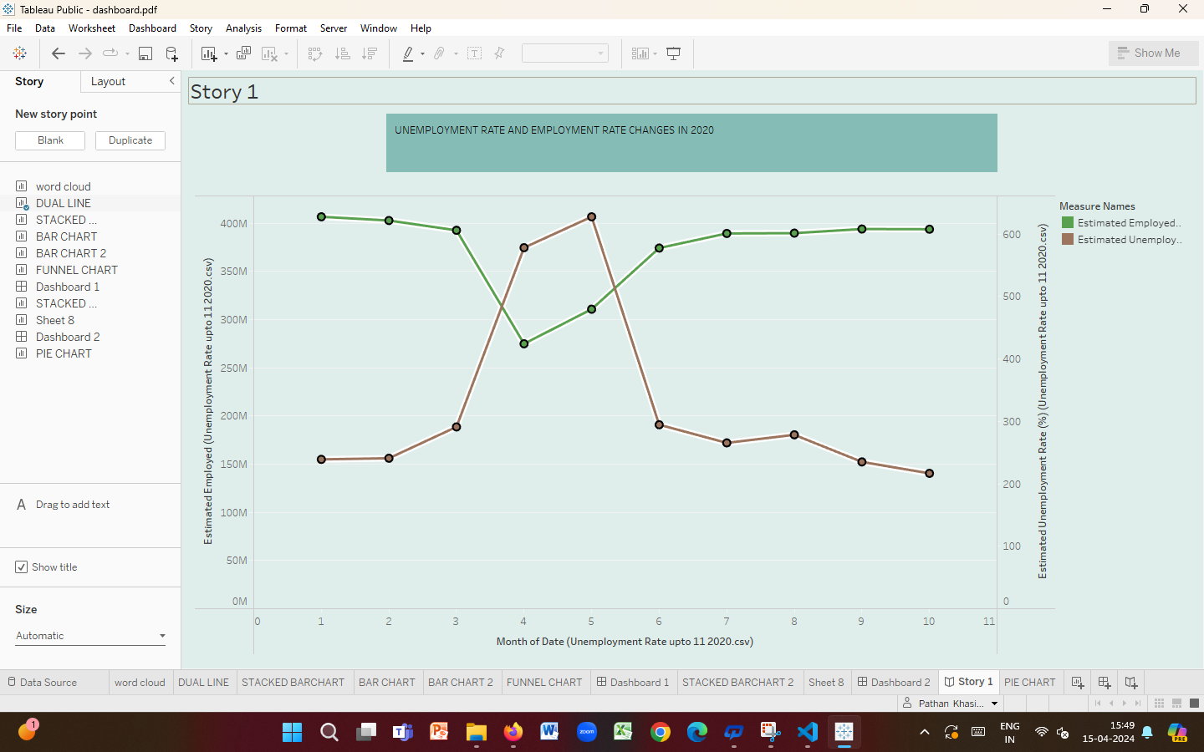

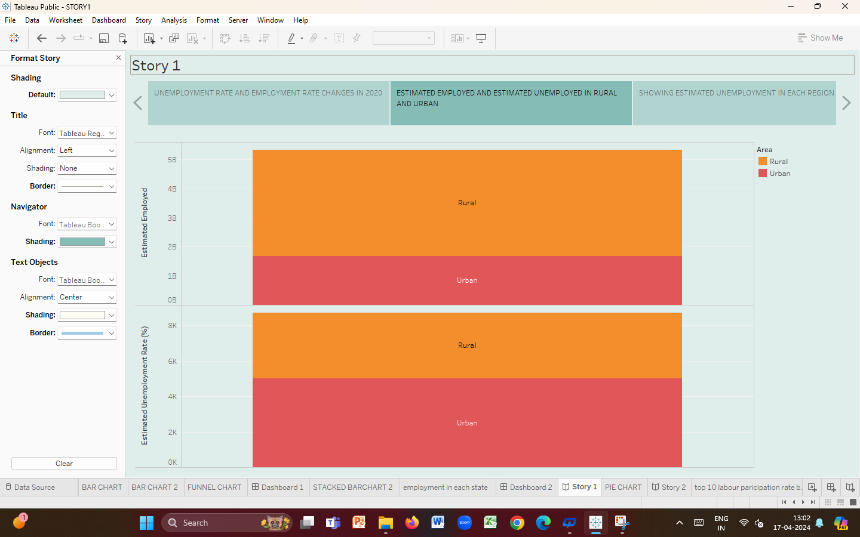

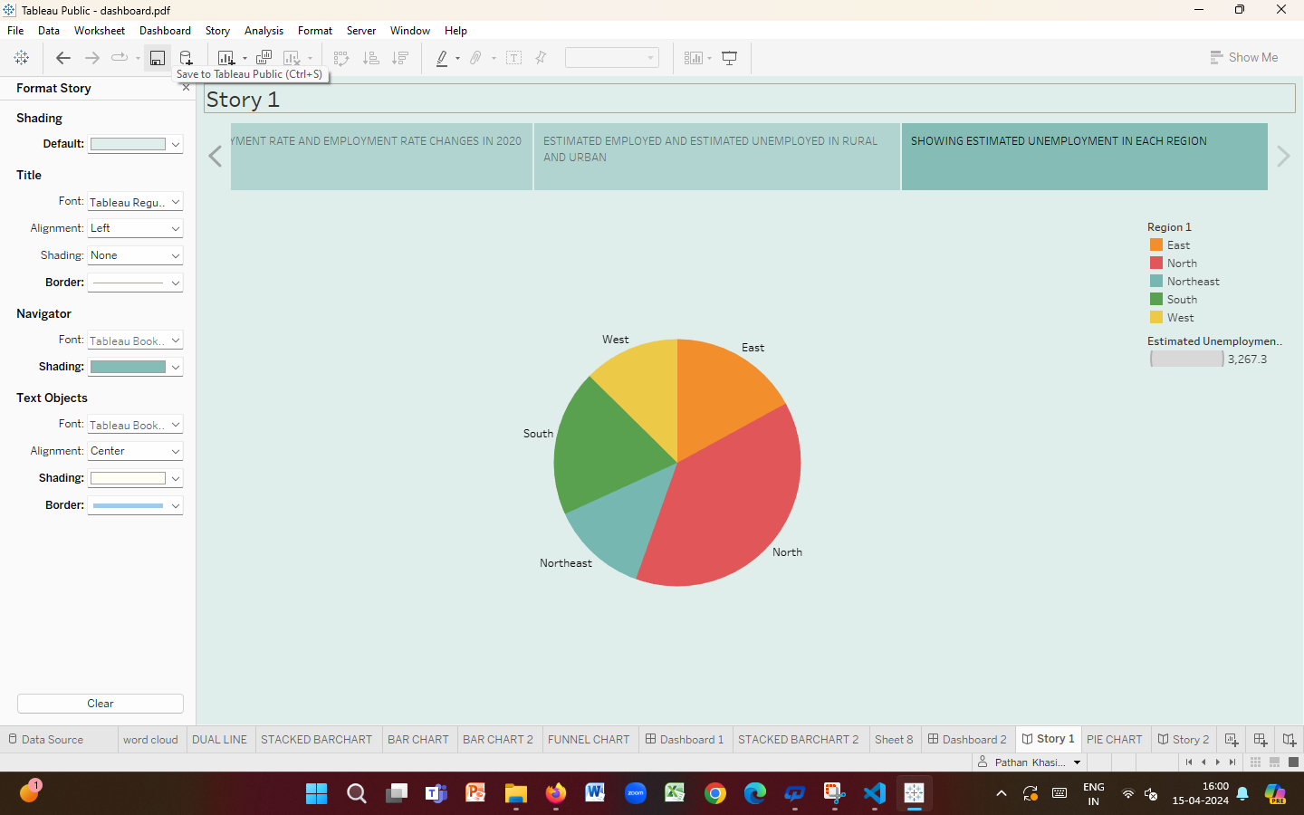

**2nd story**

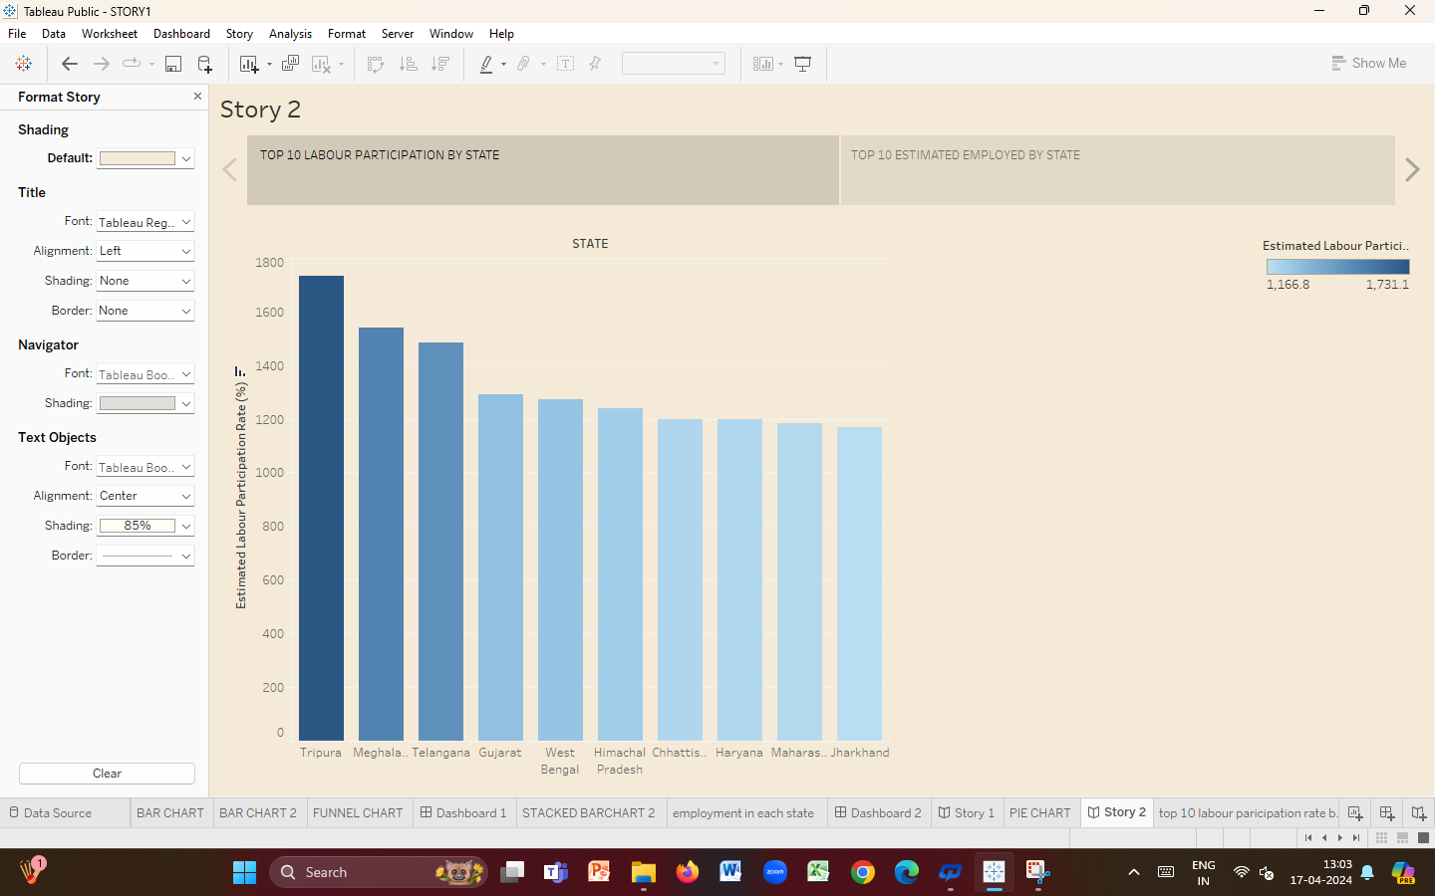

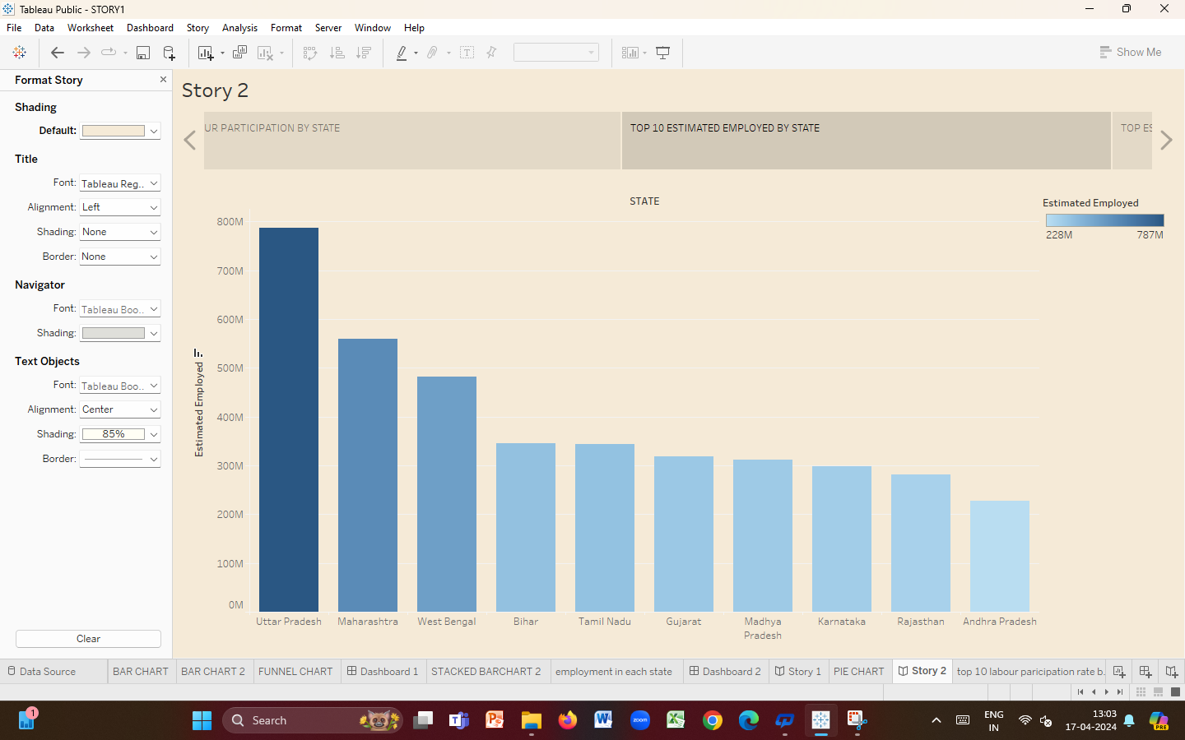

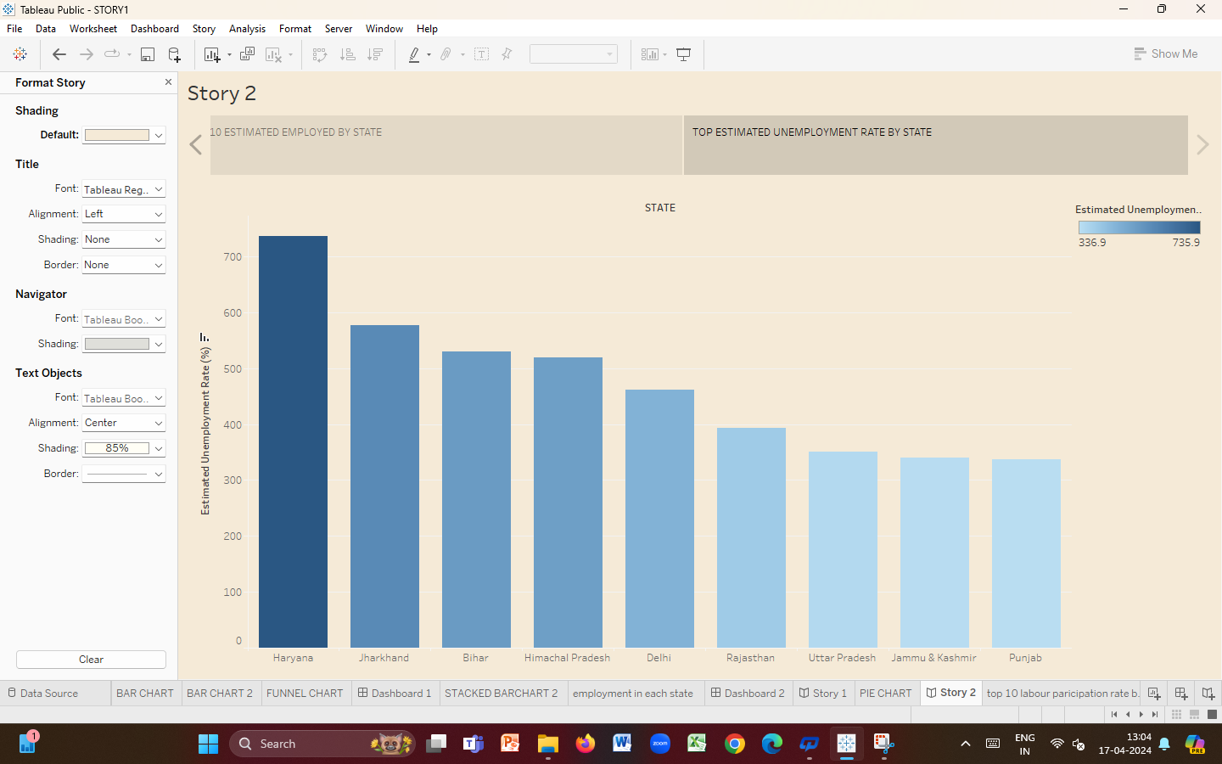

**Milestone 6: Performance Testing**

**Activity 1: Amount of Data Loaded**

**"Amount of Data Loaded" refers to the quantity or volume of data that has been imported, retrieved, or loaded into a system, software application, database, or any other data storage or processing environment. It's a measure of how much data has been successfully processed and made available for analysis, manipulation, or use within the system.**

**Fields**

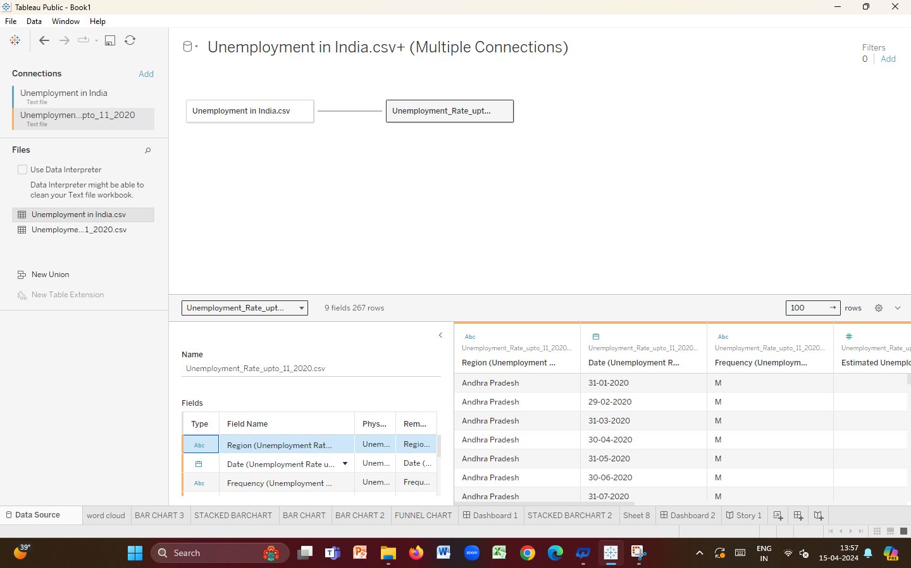

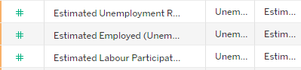

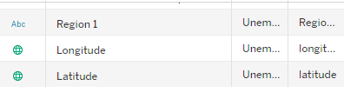

**Activity 2: Utilization of Data Filters**

**"Utilization of Filters" refers to the application or use of filters within a system, software application, or data processing pipeline to selectively extract, manipulate, or analyse data based on specified criteria or conditions.**

**Activity 2.1: “Top 10” as a filter**







**Activity 4: No of visualizations/graphs**

1. **Estimated Unemployment rate in each state**
2. **Estimated Unemployment rate in each month**
3. **Estimated employment and unemployment rate in month of date**
4. **Estimated employment rate in top 10 states**
5. **Estimated employment in each state**
6. **Estimated unemployment rate in each region**
7. **Estimated labour participation, unemployment rate up to 11 2020**
8. **Estimated employment and unemployment in rural and urban**
9. **Top 10 Labour participation rate by area**
10. **Top estimated unemployment rate by state**
11. **Employment and unemployment rate in 2019,2020**
12. **Estimated unemployment rate up to 11 2020 in each region**
13. **Showing estimated employment and unemployment in dual line**
14. **Showing estimated labour participation and unemployment in dual line**

**Milestone 7: Web integration**

**Publishing helps us to track and monitor key performance metrics, to communicate results and progress help a publisher stay informed ,make better decisions, and communicate their performance to others.**

**Publishing dashboards and stories to tableau public**

**Step 1: Go to Dashboard/story, click on share button on the top ribbon**



**Give the server address of your tableau public account and click on connect.**

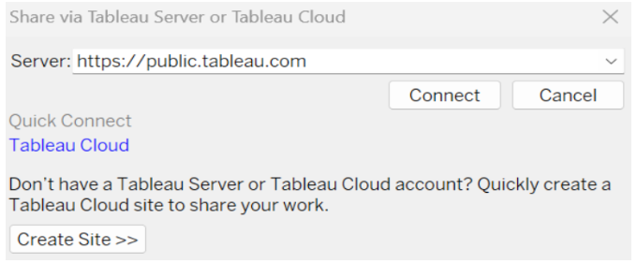

**Step 2: Once you click on connect it will ask you for tableau public user name and password.**

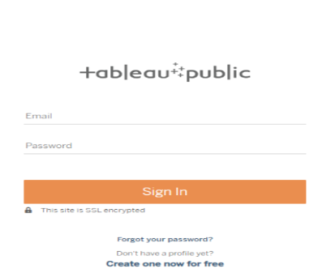

**Once you login into your tableau public using the credentials, the particular visualization will be published into tableau public**

**Note: While publishing the visualization to the public, the respective sheet will get published when you click on share option.**

**Activity 1: Dashboard and Story embed with UI with Flask**

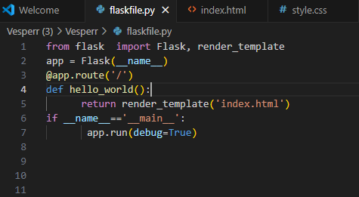

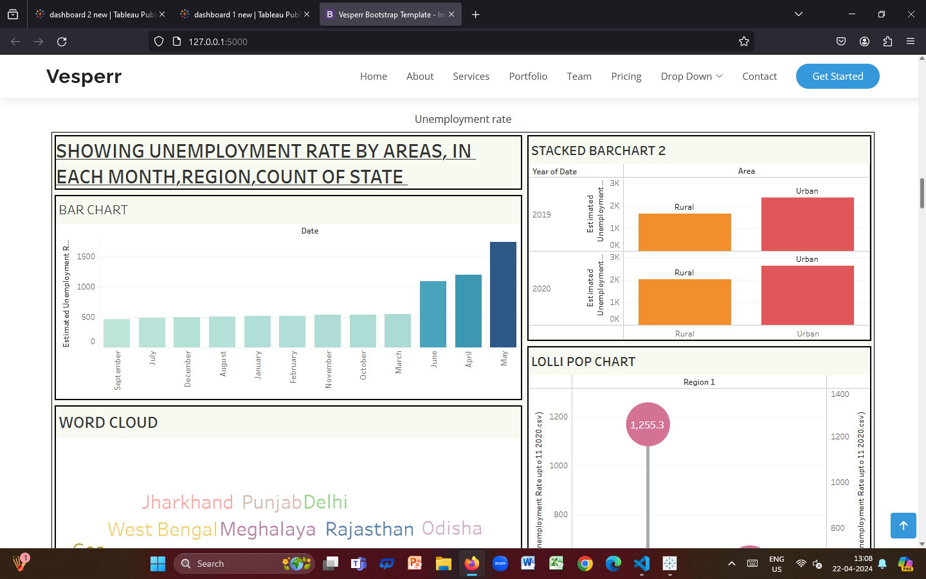

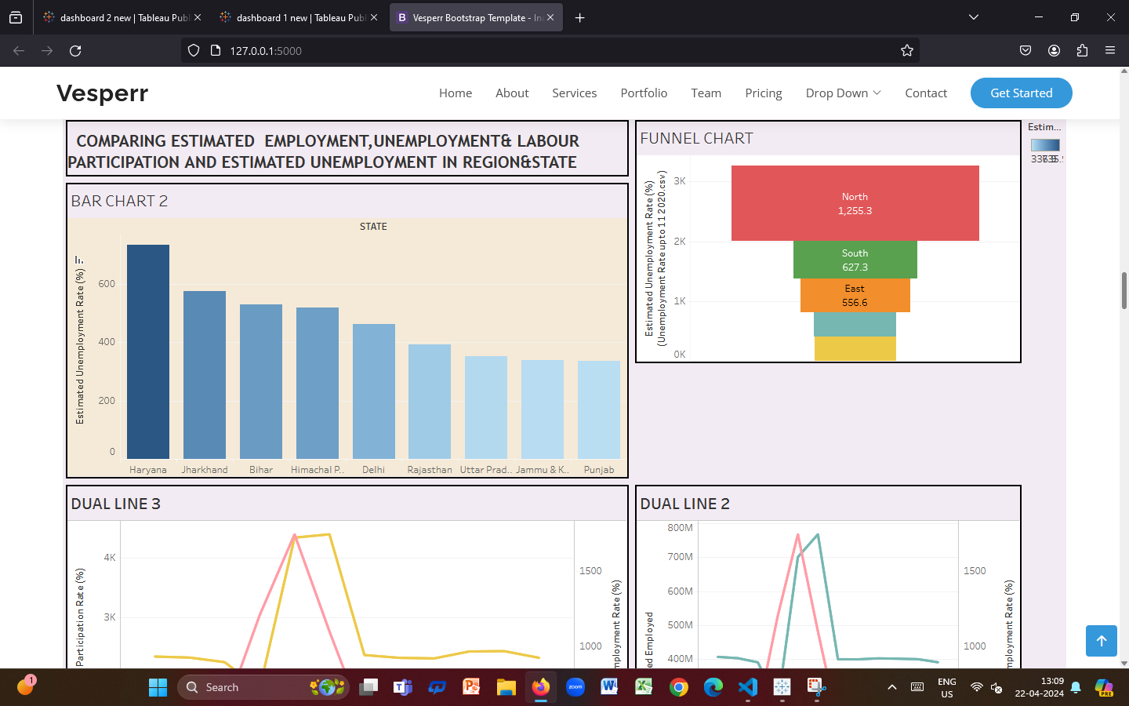

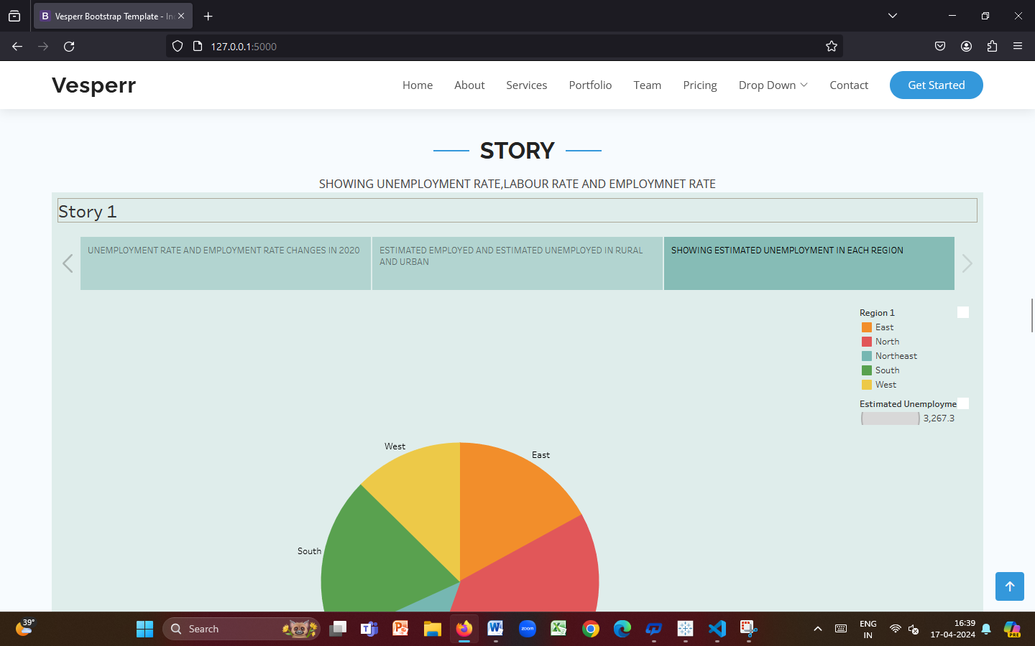

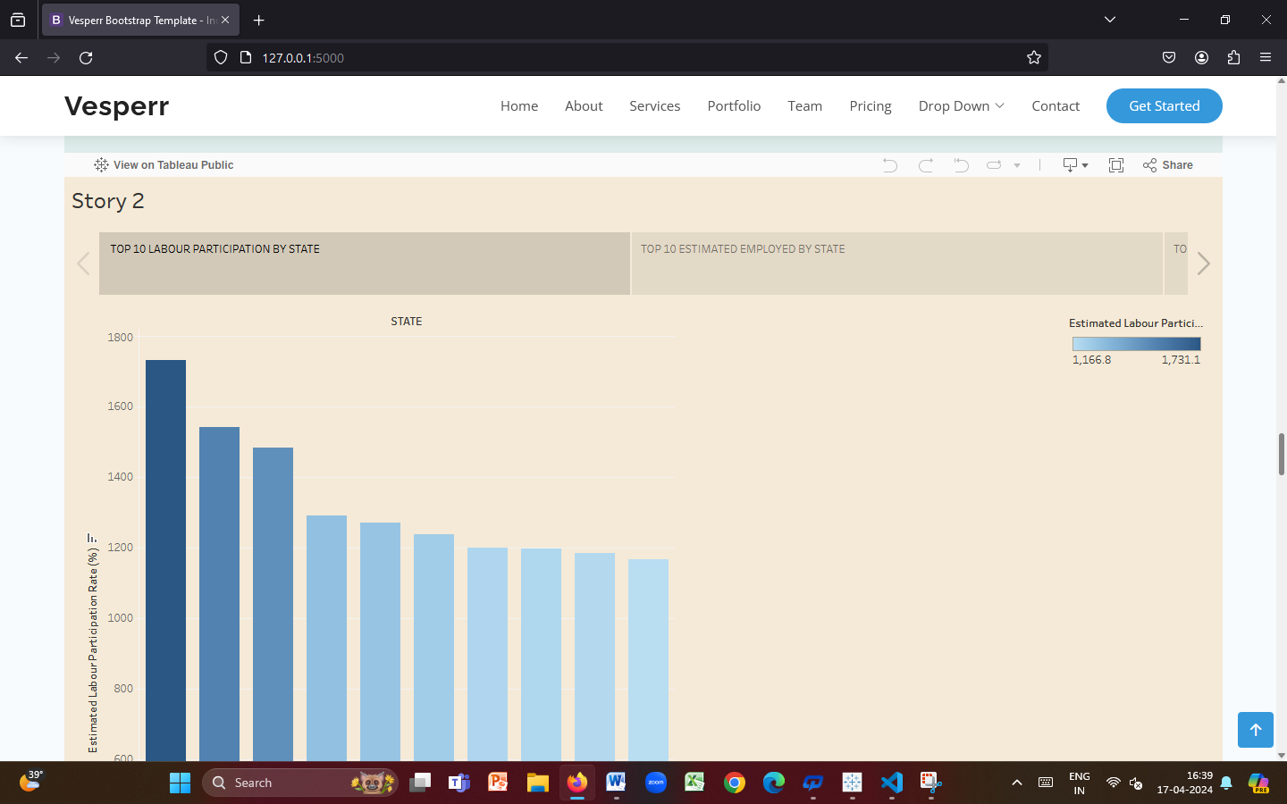

**Milestone 8: Project Documentation**

**Below mentioned deliverables are submitted along with other deliverables**

**Project documentation step by step project development procedur**